LAB 1

TIC TAC TOE OUTPUT

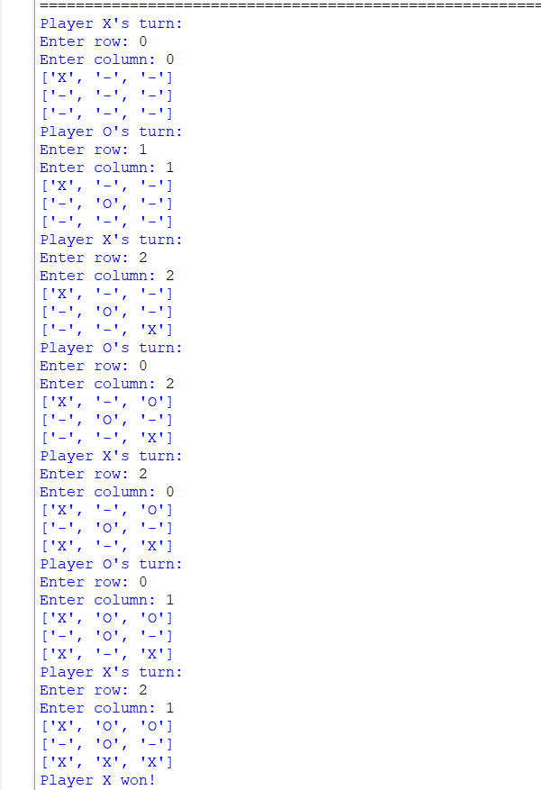

VACUUM CLEANER AGENT

